**Project 02_02_01**

In this Project we will build a series of PHP applications to test our knowledge of the unit. Be sure to document al of your code to indicate your understanding.

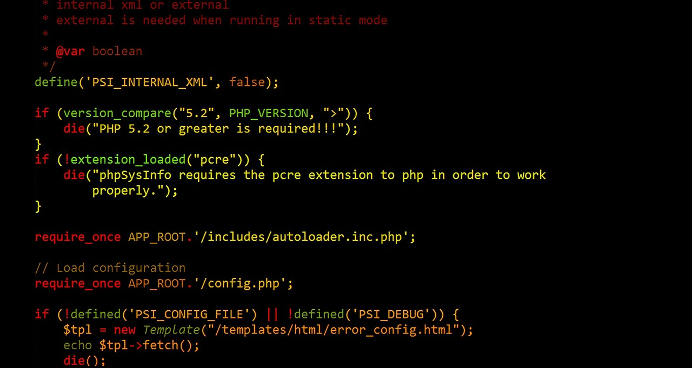 

**Part 01**

1. Create a new file called ***ConditionalScript.php***. Scaffold a basic HTML code layout into it. Set the <title> to ***Conditional Script***. Make sure to have the ***modernizr*** <script> linked in. Perform a server/browser test.
2. Add an ***<h2>*** element to the body with the content set to ***Conditional Script***. Place a set of PHP standard ***script*** ***delimiters*** in the <body> of the document.
3. Add the following code, containing a ***conditional*** statement, to the script:  
    <?php  
    ***$intVariable = 75;  
    $result = "";  
    ($intVariable > 100) ? $result = '$intVariable is greater than  
    100' :   
    $result = '$intVariable is less than or equal to 100';  
    echo '<h3>$result: ' . "$result</h3>";***  
    ?>  
   Do a server and browser test on this, changing the value of ***$intVariable*** for testing.
4. Replace the conditional statement with an ***if…else*** structure. Do a server and browser test on this, changing the value of ***$intVariable*** for testing.

**Part 02**

1. Create a new file called ***OddNumbers.php***. Scaffold a basic HTML code layout into it. Set the <title> to ***Odd Numbers***. Make sure to have the ***modernizr*** <script> linked in. Perform a server/browser test.
2. Add an ***<h2>*** element to the body with the content set to ***Odd Numbers***. Place a set of PHP standard ***script*** ***delimiters*** in the <body> of the document.
3. Write a script that displays all of the odd numbers between 1 and 100 using a ***while*** loop.

**Part 03**

1. Create a new file called ***WhileLogic.php***. Scaffold a basic HTML code layout into it. Set the <title> to ***Is Even***. Make sure to have the ***modernizr*** <script> linked in. Perform a server/browser test.
2. Add an ***<h2>*** element to the body with the content set to ***While Logic***. Place a set of PHP standard ***script*** ***delimiters*** in the <body> of the document.
3. Add the following code, containing a ***while*** loop and a ***foreach*** loop, to the script. The code should fill the array with the numbers 1 through 100, then display them on the page. It contains several logic flaws which you must fix:  
    ***<?php  
    $counter = 0;  
    while ($counter > 100) {  
    $numbers[] = $counter;  
    ++$counter;  
    }  
    foreach ($count as $currentNum) {  
    echo "$currentNum<br>";  
    }  
    ?>***  
   Do a server and browser test on this, and there should be an error.
4. Fix the script and retest.

**Part 04**

1. Create a new file called ***GasPrices.php***. Scaffold a basic HTML code layout into it. Set the <title> to ***Gas Prices***. Make sure to have the ***modernizr*** <script> linked in. Perform a server/browser test.
2. Add an ***<h2>*** element to the body with the content set to ***Gas Prices***. Place a set of PHP standard ***script*** ***delimiters*** in the <body> of the document.
3. Add the following code, containing a variable declaration and nested ***if*** statements, to the script:  
    ***<?php  
    $gasPrice = 2.57;  
    if ($gasPrice >= 2) {  
    if ($gasPrice <= 3) {  
    echo "<p>Gas prices are between $2.00 and   
    $3.00.</p>";  
    }  
    }***  
   Do a server and browser test on this, and there should be good output. Test for multiple values of ***$gasPrice***.
4. Convert the previous ***nested if*** statement into a ***single if*** statement which uses ***logical*** operators. Test for multiple values of ***$gasPrice***.
5. Add an else statement which displays ***Gas prices are not between $2.00 and $3.00.*** Test for multiple values of ***$gasPrice***.

**Part 05**

1. Create a new file called ***CoastCityComputers.php***. Scaffold a basic HTML code layout into it. Set the <title> to ***Coast City Computers***. Make sure to have the ***modernizr*** <script> linked in. Perform a server/browser test.
2. Add the following HTML code to the document ***<body>***  
   ***<h2>Memorial Day Sale</h2>  
    <ul>  
    <li>Compaq Presario m2007us Notebook:  
    <strong>$799.99</strong></li>  
    <li>Epson Stylus CX6600 Color All-In-One Printer,   
    Print/Copy/Scan:<strong>$699.99</strong></li>  
    <li>Proview Technology Inc. KDS K715s 17-inch LCD   
    Monitor, Silver/Black:<strong>$199.99</strong></li>  
    <li>Hawking Technology Hi-Speed Wireless-AC Cardbus   
    Card:<strong>$9.99</strong></li>  
    </ul>***Do a server and browser test on this, and there should be good output.
3. Create a new file called ***inc_header.php***. Do not scaffold any basic HTML template items into it. Just add the following HTML snippet:  
   ***<h1>Coast City Computers</h1>  
   <strong>Buy Online or Call 1-800-555-1212</strong>  
   <hr>***
4. Add the following PHP script to the beginning of the document ***<body>*** in ***CoastCityComputers.php***:  
   <body>  
    ***<?php include("inc_header.php"); ?>***  
   Do a server and browser test on this, and there should be good output.
5. Create a new file called ***inc_footer.php***. Do not scaffold any basic HTML template items into it. Just add the following HTML snippet:  
   ***<hr>  
   <strong>Updated</strong>&nbsp;06 January, 2017<br>  
   &copy; 2017 by Coast City Computers<br>  
   All Rights Reserved.***
6. Add the following PHP script to the end of the document ***<body>*** in ***CoastCityComputers.php***:  
    ***<?php include("inc_footer.php"); ?>  
   </body>***  
   Do a server and browser test on this, and there should be good output.

**Part 06**

1. Create a new file called ***TempConversion.php***. Scaffold a basic HTML code layout into it. Set the <title> and make sure to have the ***modernizr*** <script> linked in. Perform a server/browser test. Add a nice heading element to the <>body.
2. Write a script that displays a list of the Celsius equivalents of zero degrees Fahrenheit through 100 degrees Fahrenheit. Display both of the temperatures side by side. To convert Fahrenheit to Celsius, subtract 32 from the Fahrenheit temperature, and then multiply the remainder by (5/9).